LISTENING 1 (Items 1-5) (5 marks)
You’re going to hear five people speaking. Where are they?
Listen twice and for each item, shade in the bubble under the correct option.
 | gift shop | ticket  office | aviary | enclosure | restaurant | playground
1.
2.
3.
4.
5.

LISTENING 2 (Items 6-10) (5 marks)
You are going to hear a paragraph about Camping.
Listen and for each item, write a short answer (not more than FOUR WORDS)..

6. When did the family go camping?

__________________________________________

7. Who set up the tent?

___________________________________________

8. What was the title of the book?

___________________________________________

9. What did the family eat?

_________________________________________________.

10. Which story did they enjoy the most?

_________________________________________________.

LISTENING
SCORE

READING 1 (Items 1-4) (4 marks)
Match the texts with the pictures.
For each text, shade in the bubble under the correct option.

A. | 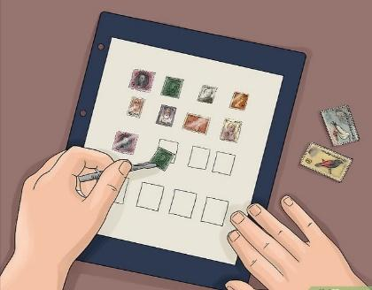 | B. | 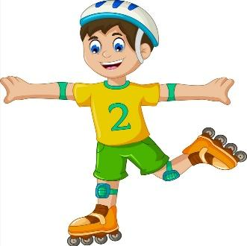 | C. | 
D. |  | 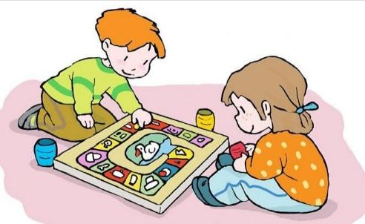  E. |  | F. | 
 |  | Pictures
 | Texts | A | B | C | D | E | F
1.  2. | Sami likes skating. He skates every Friday in his free time. He enjoys moving fast and jumping.  Rashid plays board games with his sister in his free time. He always wins.
3. | Ahmed loves taking photo. He joined a club to practice his hobby to be more skilful.
4. | Reem and her friends like to use computer in their free time. They watch YouTube and play some games.
5. | Tom is 13 years old. He collects a lot of stamps. He enjoys having album of stamps from different countries.
READING 2 (Items 5–10) (6 marks)
Read the text. Then complete the task.

The world's oceans are becoming more and more polluted. I belief that humans are responsible for this pollution. Therefore, it is our duty to clean up the oceans around the world for future generation. To begin, most of the pollution in our ocean start on the land. People throw rubbish on the beaches and it ends up in the ocean. Also factories throw their waste into the water. Many people and animals are affected by ocean pollution. In fact, more than 70% of the earth's surfaces covered with ocean water, so it will be hard not to be affected by pollution. For example, animals may get wrapped in plastic bags in the water as dolphins or turtles. Sometimes they eat these plastic bags. Not only animals are victims of the pollution, humans themselves are also affected by ocean pollution. They eat seafood that may contain chemicals and heavy metals. What can we do about this problem?
First of all, everyone needs to help to keep beaches and ocean clean. They shouldn't throw their trash and rubbish on the sea. Conservation organizations and charity work hard to pick up the rubbish and clean oil spills. Moreover, billions of dollars are spent to save endangered sea animals. It is important to share in solving this problem either by spending your efforts or money.

READING 2 (continued)

For each item, shade in the bubble next to the correct option.

6. | The writer believes that ……….... are responsible for ocean pollution.
 |  | animals |  | plants |  | humans
7. | Most of the pollution in our ocean start on the ………………..
 |  | land |  | air |  |  | water
8. | More than ……………… of the earth's surfaces covered with ocean water.
 |  | 30% |  | 60% |  |  | 70%
9. | Humans are also victims of ocean pollution because they are affected by ………………
 |  | eating seafood |  | sleeping early |  |  | travelling
10. | ……………… of dollars are spent to save endangered sea animals.
 |  | Thousands |  | Hundreds |  |  | Billions

Listening scripts
Listening scripts grade (8) 2021 First Sem

Listening 1
- Wow here are many colorful nice birds. We can see beautiful types of them such as parrots, sparrow, pigeons and doves.
- We are now in an area as a park where it has different outdoor toys as slide, roundabout and see-saw. Children can play and enjoy their time in this area.
- Here are lots of attractive presents. Visitors can buy some for their kids.
- Visitors here can take a rest and have some delicious food or meals.
- This is the first place visitors find. They can't enter the zoo without passing it to get entry permission.

Listening 2
Last month my family and I went camping to the forest. We arrived at the evening and my father told each one what had to do. My dad and my brother, Peter, set up the tent. They took half an hour to prepare the tent. My mom and my little sister, Sara, collected sticks to start a bonfire. Once the tent was set up, my father took a rest and started reading a book about travelling. My brother and little sister looked for long pointy sticks to use them for looking hotdogs over the fire while the fire was heating up. They found four perfect sticks, one for each of them.
My parents, Sara and Peter placed two hotdogs on their sticks and cooked them. They were delicious. After eating the hotdogs, the father started to tell stories for the two sons. The little sister slept early because she was tired. They enjoyed the story of three rabbits a lot. He also told them some jokes. Finally, they slept at 8:30 p.m .

